TASK 5 – Static Members and Object Life Cycle
Student Name: B. Muni Chandini
Register Number: 192524283

1. Where Static Variables are Needed
Static Variable | Why it must be static | What would go wrong if it was instance variable
nextTicketNo | Ticket numbers must be unique across the whole system | Each object would start from 1001 → duplicate ticket numbers
totalTicketsIssued | We need one common counter for the entire application | Every ticket object would keep its own count (useless)
2. Where Static Methods are Appropriate
- getTotalTicketsIssued() → returns class-level information
- getNextTicketNo() → returns class-level information
These methods do not depend on any particular ticket object, so they are declared static.
3. Object Life Cycle of a ParkingTicket
- Creation → new ParkingTicket(...) → object is created in the Heap
- In Use → while any reference (t1, t2…) points to it, the object is alive
- Eligible for GC → when the last reference is set to null or goes out of scope
- Destroyed → Garbage Collector reclaims the memory (we cannot force it, only suggest with System.gc())
In the program:
- When we do t2 = null;, the second ParkingTicket object becomes eligible for garbage collection.
4. How objects are passed and returned
- Objects are passed by reference (the reference value is copied).
- When a method returns an object, it returns the reference.
5. Alternative Concept and Complexity Analysis
Current Design: nextTicketNo is static
Alternative: Make nextTicketNo an instance variable of ParkingFacility
Situation | Static counter (my design) | Instance variable in ParkingFacility
One parking facility | Works perfectly | Also works
Two facilities (North & South gate) | Still unique ticket numbers | Each facility will have its own series (1001, 1001…) → duplicate numbers possible
Space used | Only one integer | One integer per facility
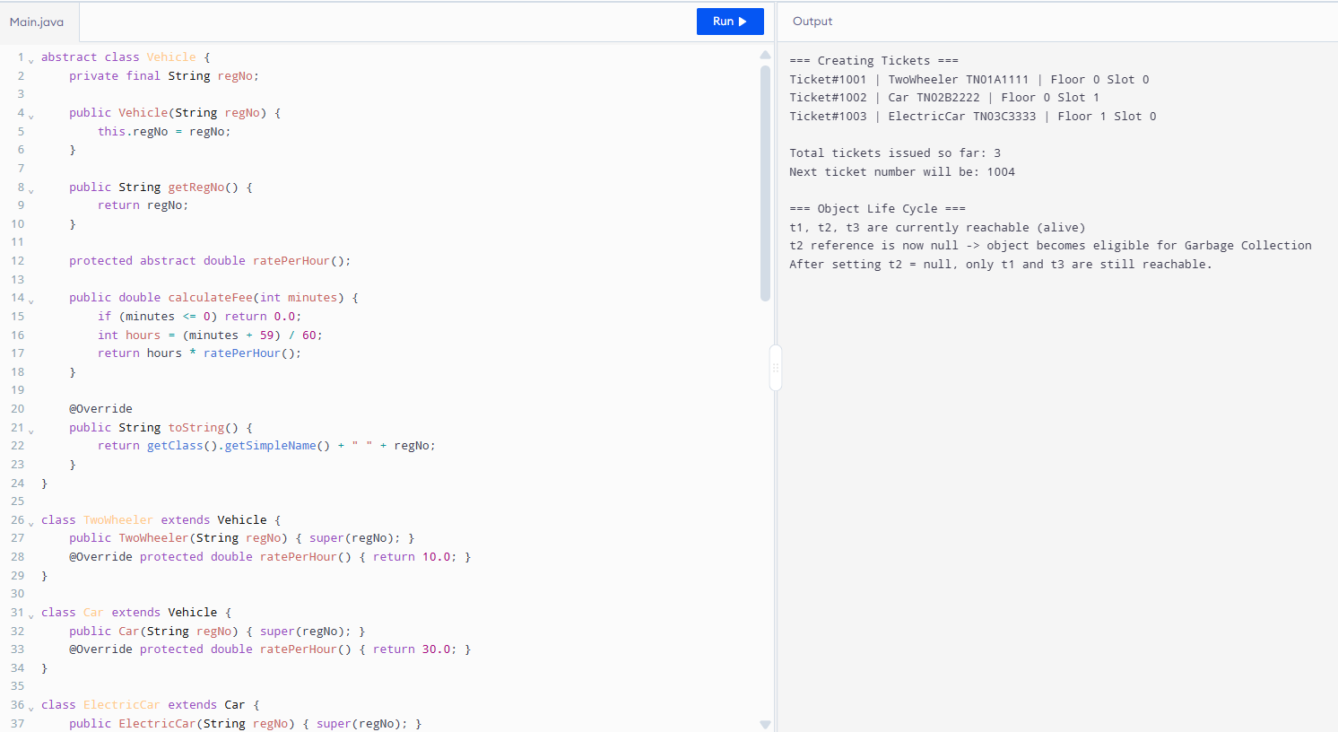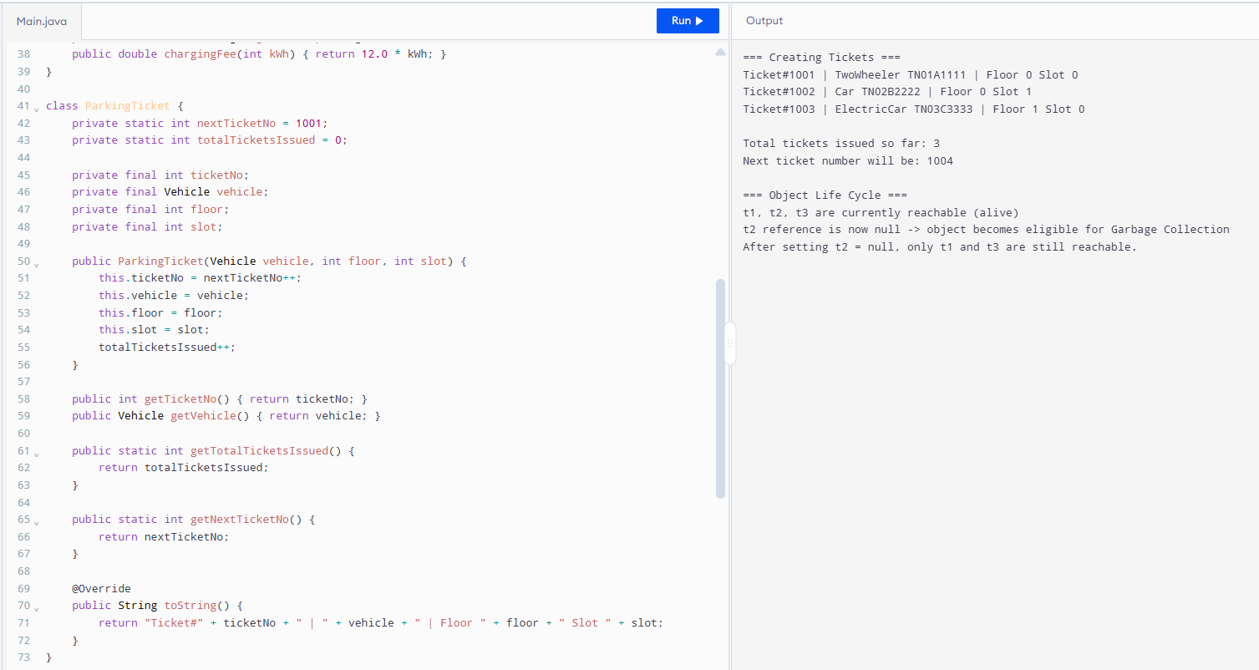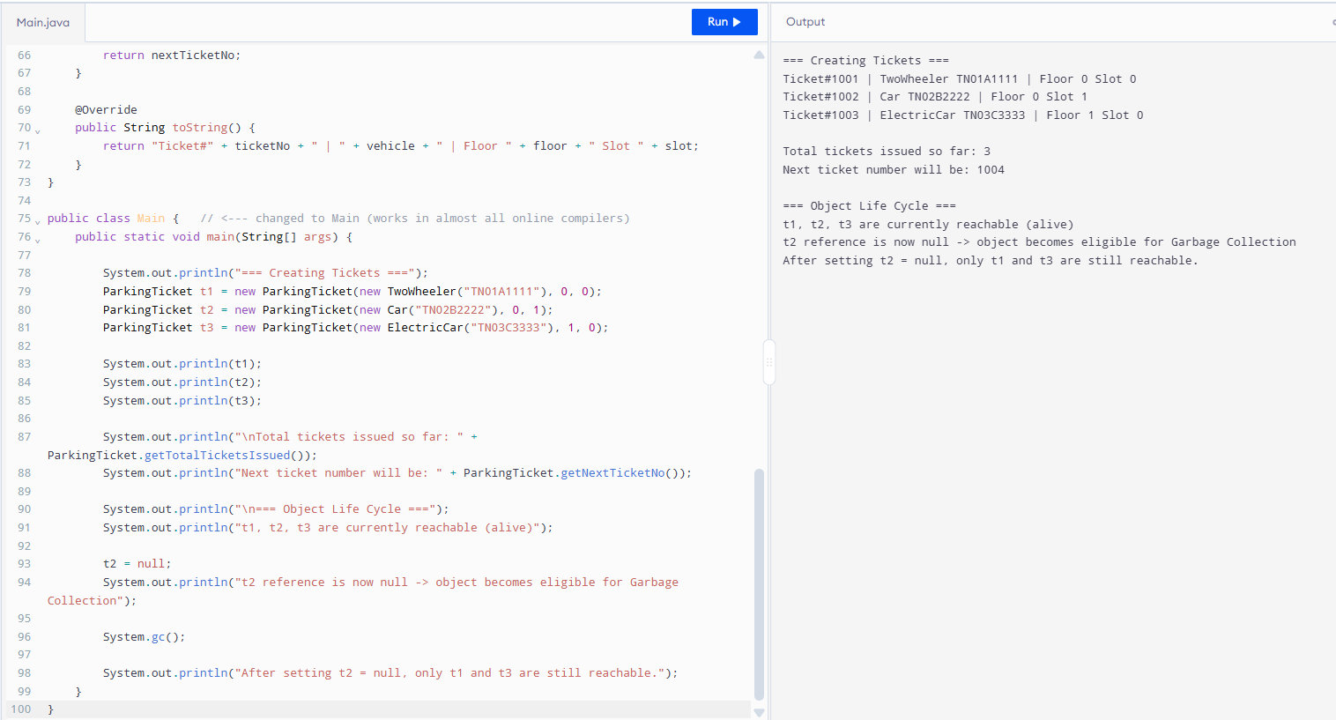Conclusion:
Keeping the ticket counter static is better because ticket numbers should be unique across the entire campus, even if multiple ParkingFacility objects exist.

